**IBM HACK CHALLENGE - 2023**

**Report on project topic: Fire safety educator and consultant through video analytics.**

**Project domain**: Cognitive Artificial Intelligence

**Project ID :** SPS_PRO_4316

**Project title:**  Safe zone: Real-time video analytics for industrial safe

**Team name:** Blaze aware

**Team members:**

* Charulatha. M
* Shirgin. S
* Ramya.S

**Project Description:**

Safe Zone is a cutting-edge project that employs real-time video analytics to bolster industrial safety in diverse industrial environments.

The project's primary objective is to monitor and swiftly identify potential safety hazards, including unauthorized access to restricted areas, equipment malfunctions, and non-compliance with safety protocols.

Safe Zone scrutinizes live video feeds from strategically placed surveillance cameras within the industrial facility

The system adeptly recognizes objects, activities, and behaviours, providing real-time alerts to prevent accidents and enhance overall workplace safety. Safe Zone is an invaluable tool that proactively safeguards workers and assets in industrial settings.

1. **INTRODUCTION :**

**1.1– OVERVIEW :**

* Fire safety consultancy and real-time video analytics are critical components of modern safety and security strategies. They play a vital role in preventing and responding to fire incidents, ensuring the safety of people, property, and assets. This introduction provides an overview of both concepts and their significance

Fire safety consultancy :

* Fire safety consultancy involves the assessment, planning, implementation, and management of fire prevention and protection measures within various environments, such as residential, commercial, industrial, and public spaces. Fire safety consultants work closely with businesses, organizations, and building owners to ensure compliance with fire safety regulations and standards.

Real-Time Video Analytics:

* Real-time video analytics involves the use of advanced technology to analyze live video streams in real-time and extract valuable insights and information from the visual data. In the context of fire safety and security, real-time video analytics can enhance situational awareness and aid in rapid response to potential fire incidents.
* Here we build a website to educate the working people in industries or any working area to get aware about the fire safety measures and the webpage contains the registration facility user can register and upload the video footage of the accident met by there company and the web page can give the reason for the affect and also gives solutions and safety measures to avoid the same accident again to occur.
* To confirm the accuracy , we developed the model by collecting realtime data. The results are accurate by our simulation parameters when compared with the existing methods.

**1.2-PURPOSE :**

**The use of this project. What can be achieved using this.**

This website can be incredibly helpful in providing information and resources related to fire safety, prevention, and emergency preparedness. They can offer tips on creating a fire escape plan, installing smoke detectors, and using fire extinguishers.

Additionally, this website often provide guidance on how to handle different types of fires and offer educational materials for both adults and children. Overall, this website is a valuable tool for promoting fire safety and preventing accidents.

* The webpage contains the registration facility user can register and upload the video footage of the accident met by there company and the web page can give the reason for the affect and also gives solutions and safety measures to avoid the same accident again to occur.
* It has login facility for the new user and registration facility the user should register using their mail Id to upload the video and to have a interface and conversation
* It contains training sessions and courses so that the user can gain knowledge about the fire safety measures and provide guidance on how to handle different types of fires and offer educational materials for both adults and children.
* It can analysis and predict the reason for the accident and provide training to the user to safeguard them by different methods and solutions
* The course explains about the experience, methods to use different fire safety equipment and about the first aid measures if anyone troubles with the accident.
* Has fire safety consultant to give a friendly conversation and to remove about the fear handling accident The more knowledge about the safety measures reduces the occurance of the accident.

**2-LITERATURE SURVEY :**

2.0 – Existing problems :

* Purpose is to give education for the common people who had lack of knowledge about their own safety and working in the risky area like crackers manufacturing company, petrol bunk, and company that handle highly inflammable chemicals like LPG gas manufacturing company
* Beyond the higher officials and some employee has knowledge about the fire safety there are more workers and employees who didn’t studied their schooling and has lack of knowledge in the fire safety and this is the main reason for most of the fire accident and increase death rates in the accident.

**2.2 PROPOSED SOLUTION :**

* The Analytical page includes the estimation of customer the mode of Software Operation can be done in both Automatic and Semi-Automatic.
* The analytics page contain estimation of users and collecting of response.
* For every page log in , home page , Analytics , Live stream we used

HTML, CSS, Java Script . The use of python, Opencv, Numpy.

* Tensor flow for the live Page. Pedestrian detection is used to detect the

accident and to analyse the reason.

**3 – THEORITICAL ANALYSIS :**

**3.1 Class diagram**

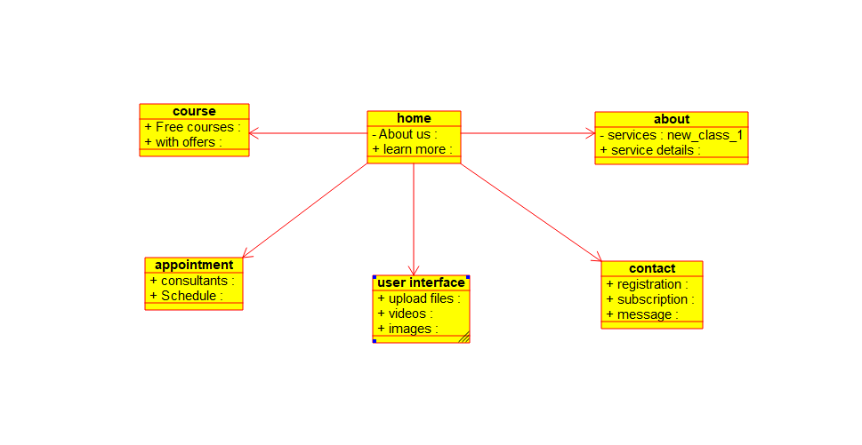

**3.2 Hardware / Software designing :** Hardware requirements of the project :

● I3 or rayzen 3 processor

● 4 Gb ram

● 2gb graphics card

● Windows or Mac or linux

Software requirements of the project : FRONT END  -  HTML , CSS , Javascript , Flask

BACKEND - Flask , python

DATABASE – NoSQL

4 - **EXPERIMENTAL INVESTIGATIONS :**

Analysis or the investigation made while working on the solution.

● So while shaping an idea about how to create a website for the proposed project, we visited a lot of websites for referrals to study about any pre existing solutions and how to make a more advanced and useful model other than the existing one .

● To check the working of the website we created , we searched to get the proper video clips to ,how the website created.

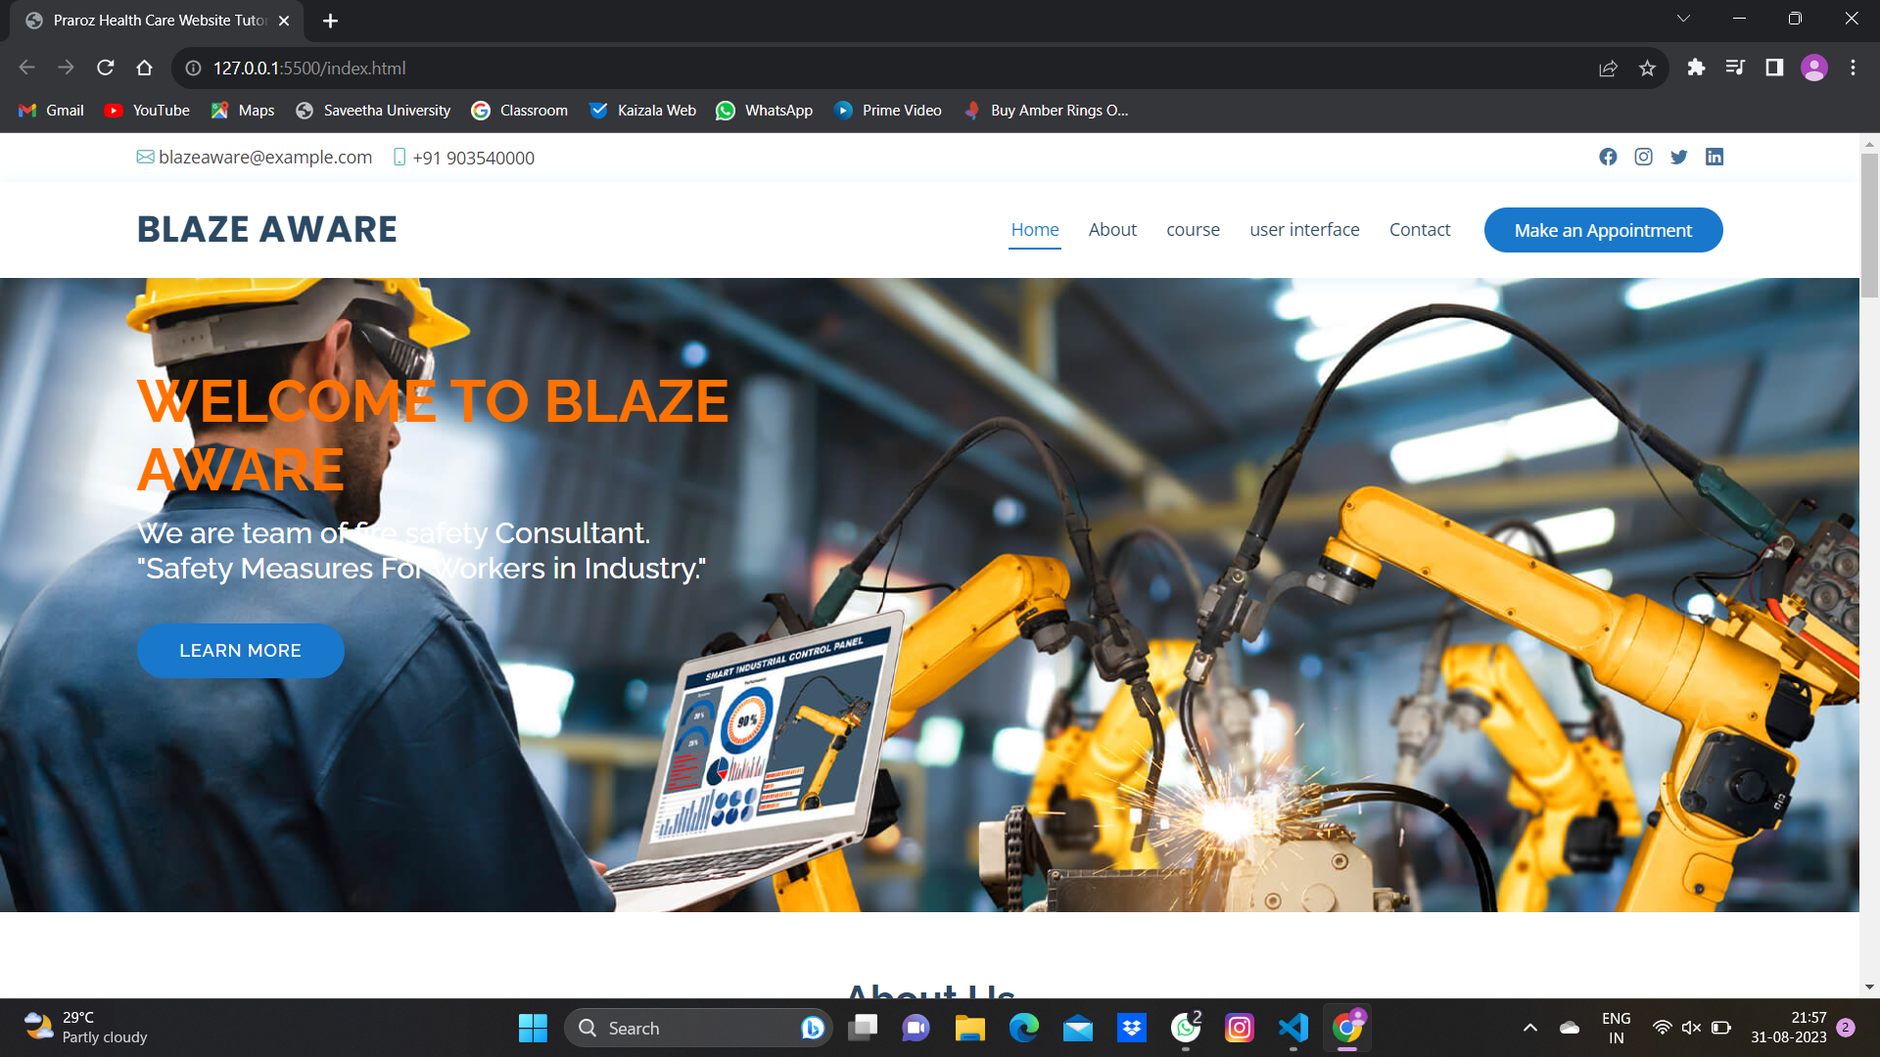

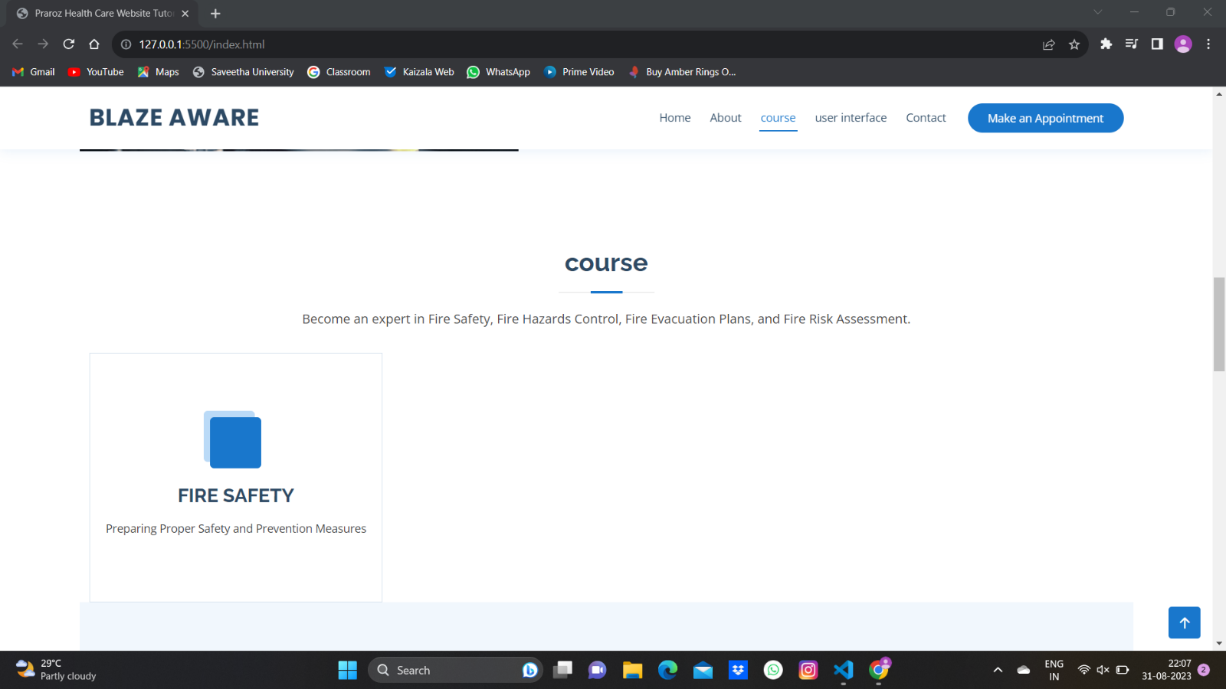

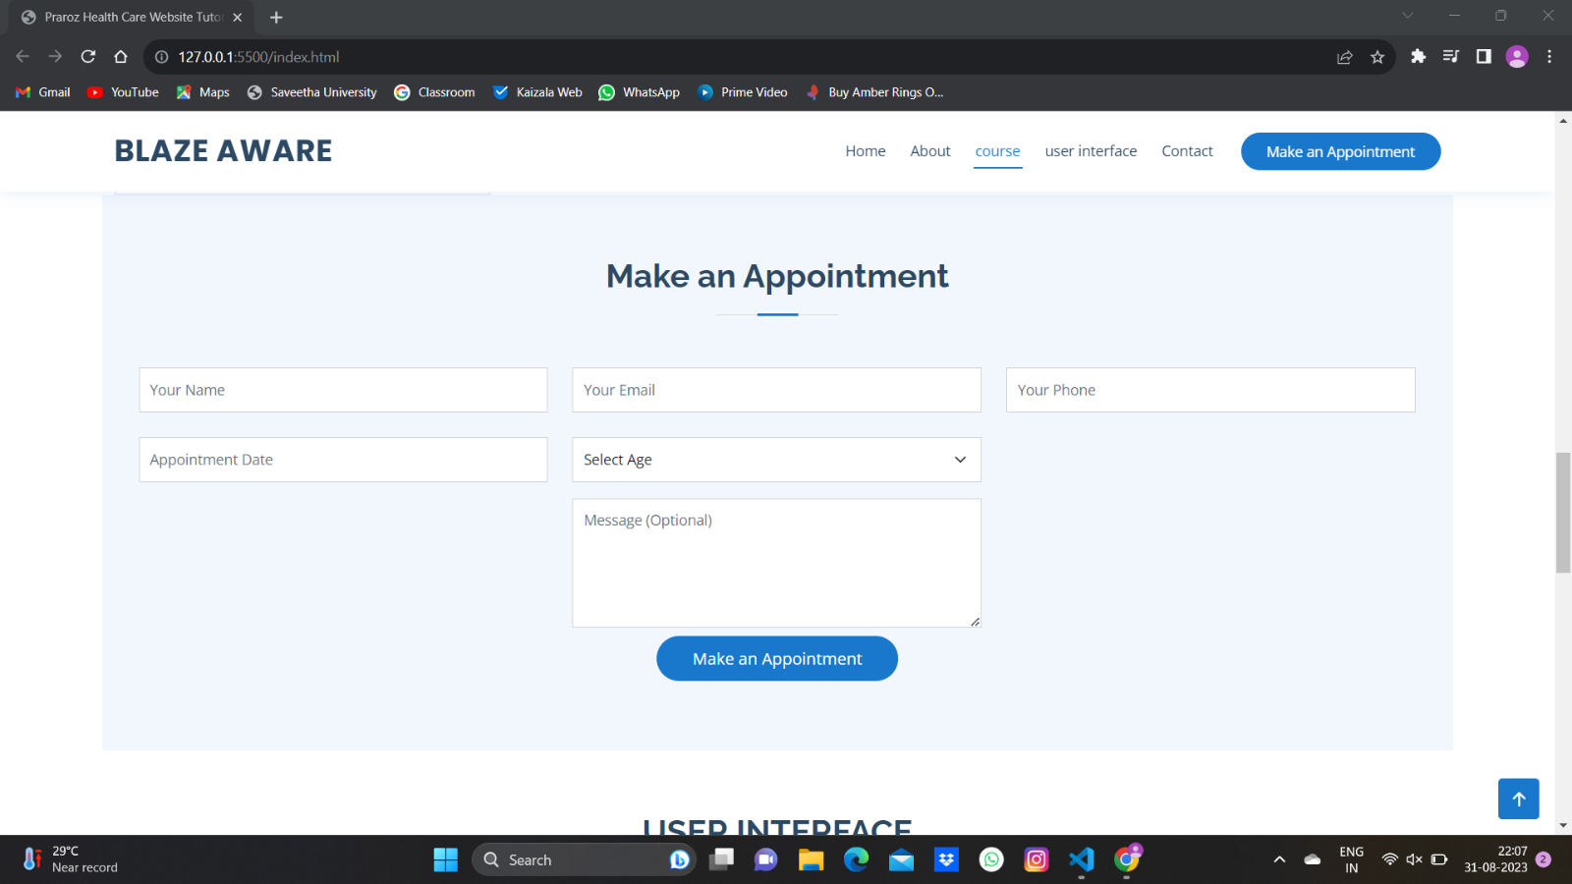

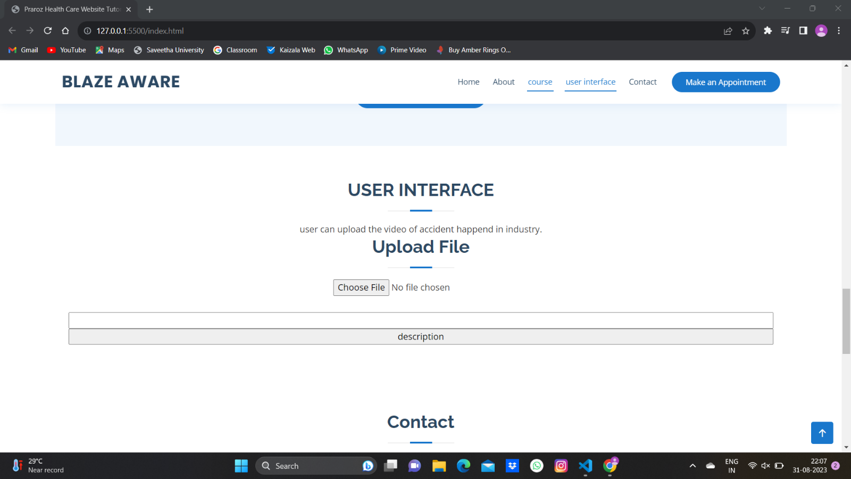

**5 - ADVANTAGES :**

Fire safety training is essential to keep the workplace clean, safe and healthy. Fire safety training courses can help employees learn the potential hazards and risks associated with fires and teach them how to prevent and respond to fire emergencies. we can provide fire safety training in many ways, including live fire training, e-learning, or with the latest in blended training software which combines both live training and support with a digital interface.

DISADVANTAGE :

It might have very less disadvantages and that will be noted by the users through the feedback method.

**8 – APPLICATIONS :**

**The areas where this solution can be applied**

The website we designed can be used in

* Industrial areas.
* Corporate regions.
* Business purpose.
* Large scale industries.
* And also in small scale industries.

**9 - FUTURE SCOPE :**

* In future this website will be widely used in the industries because they had no more time to give trainings for the frushers and to educate them about their own safety
* Hence this website educate them and consult them about the safety
* Provide the solution for the safety related accidents and strategies to avoid them a wide.

**10 - CONCLUSION :**

Fire safety consultancy and real-time video analytics are critical components of modern safety and security strategies. They play a vital role in preventing and responding to fire incidents, ensuring the safety of people, property, and assets.

Additionally, this website often provide guidance on how to handle different types of fires and offer educational materials for both adults and children

**SOURCE CODE LINK :**

[**https://github.com/smartinternz02/SBSPS-Challenge-10932-SafeZone-Real-time-Video-Analytics-for-Industrial-Safety**](https://github.com/smartinternz02/SBSPS-Challenge-10932-SafeZone-Real-time-Video-Analytics-for-Industrial-Safety)

[**https://drive.google.com/drive/folders/1g2f_YARl8iZQ84jYD6ZXuLzd6Ia3JnDL?usp=drive_link**](https://drive.google.com/drive/folders/1g2f_YARl8iZQ84jYD6ZXuLzd6Ia3JnDL?usp=drive_link)

[**https://www.youtube.com/watch?v=t6nIl-tTca0**](https://www.youtube.com/watch?v=t6nIl-tTca0)